Project Game Wizard Project Plan

Team Game Wizard

Zachary Strickler and Ethan Dowell

9/13/22

Introduction-

1. **SCOPE AND PURPOSE OF DOCUMENT**

The contents contained in this document will include the introduction, the schedule, staff organization, and the tracking and control mechanisms. The introduction includes the scope and purpose of the document as well as the system scope. The system scope includes the problem/opportunity description, the anticipated business/personal benefits, the system capabilities, and the system context. The purpose of a project plan is an overview of our management of the project.

Our application is a video game forum type app called Game Wizards. It will give the latest pots and updates about video games, including release dates, new projects by studios or companies, and releases of trailers. Our application will include forums for new game releases and game news. Game Wizard will also sort by top rated games, sort by games alphabetically, sort by popularity of a game, game genre, and the most viewed games. Our application will integrate other social media, such as Discord.

1. **SYSTEM SCOPE** 
   1. **PROBLEM/OPPORTUNITY DESCRIPTION**

The goal of this project is to create an application that solves multiple video game forum’s problems. What we are trying to solve is to make an application that combines the current forums and puts them all in one place, not needing to go to fifty different forum websites. This application will include all the news in one single place from a variety of games and companies.

* 1. **ANTICIPATED BUSINESS / PERSONAL BENEFIT**

What we hope to accomplish with our app is to ease the dissemination of information sent out by companies so they can reach their old audience easier and have a chance to reach a new audience in the first place. We also hope that by filling this niche we would be able to draw in a lot of profit to support future endeavors. Through this, we also hope to be able to be the first to deliver the news. With all of this we seek to allow all games news to be delivered properly and quickly.

The benefits for our users are similar to many other forums. The forum aspect of our website will allow users to immediately begin discussions about whatever news is released, about how they find a newly released game, and supplementary materials for said games. Along with that, we will allow users to get informed when such news is posted, they can also organize games with those they are friends with. We hope to allow our users to also make use of popular services like Twitch and Discord through our service to allow them to interact with their friends from different platforms and ease the use of videos from other platforms as well.

* 1. **SYSTEM CAPABILITIES**

The forum will have a news feed, showing news, such as game releases, new game announcements, updates on said games, among other things. We aim to have each game be its own thread, allowing you to search by name, company, and genre, to find what you want easily. It will be a website and app, allowing you to take it anywhere you go. We will also have Twitch and Discord integration to chat with your friends and watch people play the games you like with ease.

* 1. **SYSTEM CONTEXT**

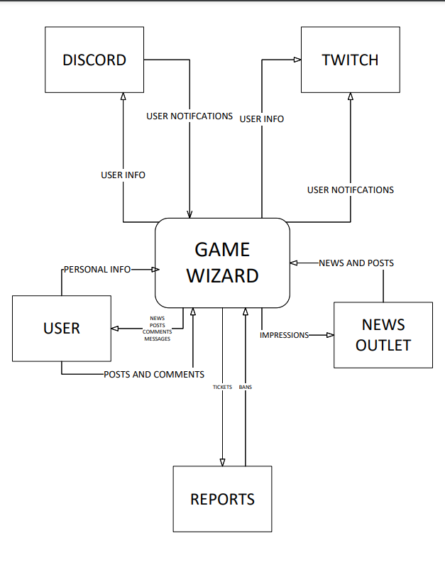

2) **SCHEDULE**

Network Diagram and Gantt Chart Included in drive, and printouts.

3) **STAFF ORGANIZATION**

Our team is organized into 2 roles, team members and team leader.

The team leader is Zack, who is responsible for making sure the group work is done on time and trying to figure out when stuff should be done. The members, Ethan and Eric are also responsible for these things, but the leader enforces it a little more and checks up on the team members. The 2 roles have no distinct difference besides the leader managing the group a little more. Sadly, toward the end of class, Eric decided to drop the class.

4) **TRACKING AND CONTROL MECHANISMS**

Our plan to track our progress is through the history feature on Google docs and Word. The timestamps of uploads and changes make it really easy to see our progress and who is doing what. Another way we plan to track our progress and to stay on task is through the Microsoft Project Project Plan we have created. We also make sure to tell each other what we plan to do in our Slack Group Chat. Finally, we also create Sprints on the Trello board to make sure that we have our weeks planned out and organized, and Trello makes it easy to do this in one spot.